\\NEWSQUASHSHARED\US Squash Documents NEW SHARED\USQ Design\READY to Use Files\Files for Use\US Squash Logos\For printing materials\Vertical.eps

2015 U.S. JUNIOR OPEN SQUASH CHAMPIONSHIPS

December 19 – 22, 2015 GROUP ENTRY FORM

**(Please type this form or complete in block capitals)**



|  |  |
| --- | --- |
| **National Association** |  |

We would like to enter the following players into the 2015 U.S. Junior Open Squash Championships:

|  |  |  |  |  |  |
| --- | --- | --- | --- | --- | --- |
|  | **Event Division** | **First Name** | **Surname/Last Name** | **Date of Birth**  **(MM/DD/YYYY)** | **National Ranking** |
| 1 |  |  |  |  |  |
| 2 |  |  |  |  |  |
| 3 |  |  |  |  |  |
| 4 |  |  |  |  |  |
| 5 |  |  |  |  |  |
| 6 |  |  |  |  |  |
| 7 |  |  |  |  |  |
| 8 |  |  |  |  |  |
| 9 |  |  |  |  |  |
| 10 |  |  |  |  |  |
| 11 |  |  |  |  |  |
| 12 |  |  |  |  |  |





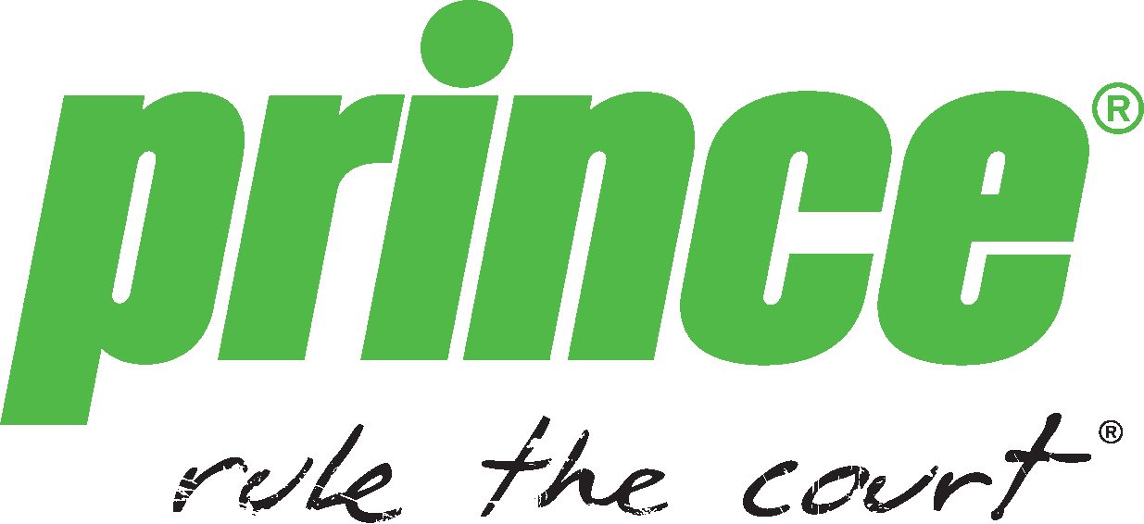

We enclose the entry fees of ______ (Number of entrants x $175.00) BEFORE **11/18/15**

OR $205.00 after deadline of **11/18/15** payable to US Squash.

Amount to be charged: ______________________________________

Credit Card Type (circle one): AMEX MASTERCARD VISA

Name on Credit Card: ______________________________________

Credit Card Number: _______________________________________

Expiration date: _____/________ Security Code: _________

Address:_____________________________

City:_____________________________

State/Province:____________________________

Country:_____________________________

Zip:______________________________

Phone: ___________________________ Email Address: ___________________________

Contact details to for main communications (This person will be responsible for distributing the start times and tournament information to the above named entrants):

|  |  |
| --- | --- |
| NAME | |
| Email: | Mobile: |
| Tel: | Title |

**By endorsing these entries, your National Association confirms that all your players and coaches in attendance are fully aware of the Regulation regarding the mandatory requirement that only eye protectors that have complied with one of the National Safety Standards for Squash will be permitted. Please see Tournament Information Page on the US Squash website, which provides details of these eye protectors. Failure to do so will result in player disqualification.**

# ENDORSEMENT BY NATIONAL ASSOCIATION

Signed: ____________________________ Name: _____________________________

Position: __________________________________ Date: _____________________